***Question # 01:***

Write a program to evaluate the area and perimeter of rectangle. Ask user to supply length and breadth separately on the same line replacing the previous statement. Output screen should only print the answer in a comprehensive way e.g.

*The area and perimeter of rectangle with length = ______ and breadth = ______ are respectively ______ and ______ units.*

*Area = wl*

*Perimeter = 2(l+w)*

***Question # 02:***

Write a program to print hollow diamond star pattern using escape sequences.

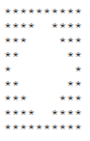

***Question # 03:***

Generate the following output. (hint: ASCII value of ☺ is 1)

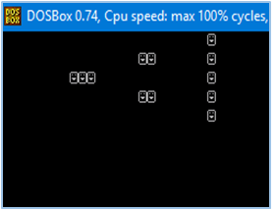

***Question # 04:***

A sweater is on sale for 25% off the original price. The original price is $50. Write

a solution to calculate and print the sale price.

***Question # 05:***

Write a C program which takes marks of subjects Physics, Chemistry, Biology, Mathematics and Computer as input from the student then Calculates his percentage and display the result card on the output screen.

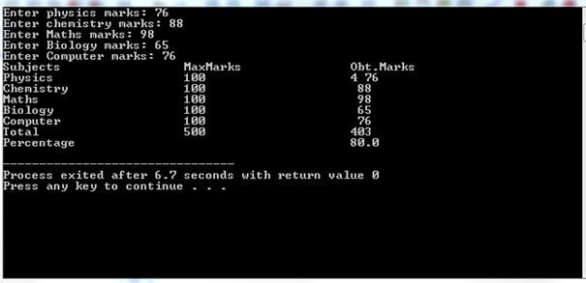

***Question # 06:***

Write a program to display the size of different data types on different lines. (Hint: Use sizeof() Function)

***Question # 07:***

Write a program that asks user to give number of days as input and returns the number of years, weeks, and days. Assume every year has 365 days and every month is of 30 days.

***Question # 08:***

Write a program which takes a character as an input and display corresponding ASCII code.

***Homework:***

Write a program which takes two integers and interchange them without using additional variable.